Bugs and new enhancement requirmements

- The insight snippet shows twice on place detail in itinerary
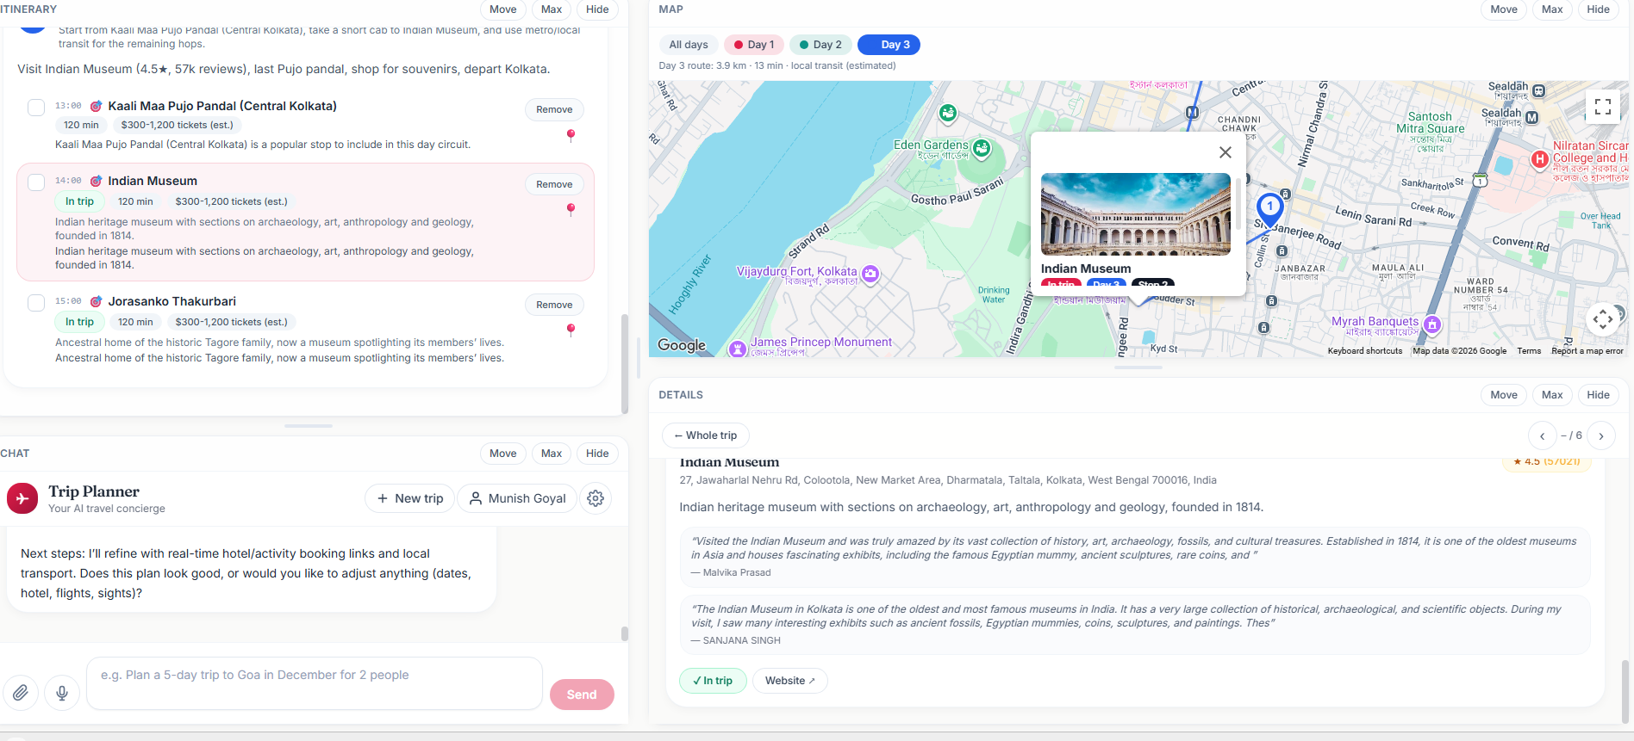

- The map place tile kind of covers the area around that place can it be shown bit on side non intrusive. And make it clickable to load details of that place in details section.
- Can you allow adding new places to trip from the map directly, just like gooogle maps has a feature of add stop.
- The details section currently is limited to only the items in itinerary. Figure out a good user experience to show more recommended places , hotels etc. for user to select through if they want to make changes.
Also do we have to limit ourselves to being just one page fixed in length, can this page we make scrollable vertically so to add these additional places and their photos/reviews wetc. All the usual details . Figure a good fluidic and inituitve user experience and suggest.
Chat size should be just small size, mainly user will need map, and details section. Itinerary also can be a relatively medium to small size.

Already resolved – DON’T go through below issues
- Even though hotel was updated by user to Hyatt instead of original ITC the H marker in map is still on ITC old hotel.
- Add these data points to each place in the itinerary section. Itinerary section is the main that user will finally use
  - Approx. time to spend there
  - Opening timings/holiday days etc. (try that it should not be added to a holiday day – highlight in different color coding if something in itinerary you have concerns on)
  - Approx. cost (tickets, or restaurant meal cost, etc.)
  - Show a small summary on how to reach the stops – e.e.g hire a taxi from hotel to reach stop1, then take a metro to stop2 etc.
  - Add 1-2 line insights for that place in the itinerary section

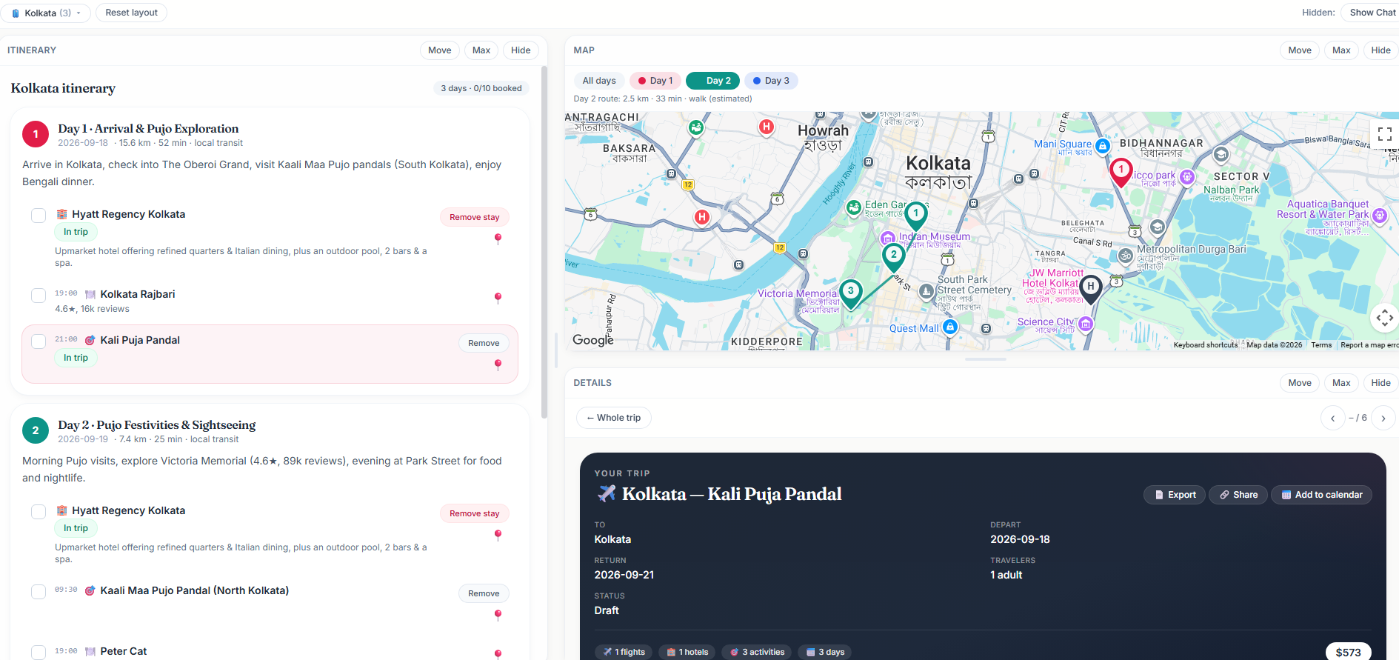

- When exporting PDF, add the map snippet of the circuit for each itinerary day.
- Possible to add a scanner or some way that user can just easily take all the stops for the day and enter in their google maps and it shows them full circuit for the day. From itinerary each day instead of manually adding, some easy way to feed to gogole maps when theya re actually in their trip. They will use the trip itinerary pdf or printout as their main reference while on trip.
- Clicking on place map tile should update and show it in details section and highlight /scroll to that palce in the itinerary section. All sections make consistent, clicks on a aplace in any section should update scroll/highlight or zoom dpeending on seciton type in all the sectrions. Think from a better user experience to allow for making fast changes and research to build the right itinerary. That is the primary goal of this app.

Maximum heavy lifting to be done by the agent and with neede dinoput from user, user should be abel to make changes, do R&D

